**DevOps Tutorial: Automating Web Application using Jenkins, Docker and GitHub.**

We have two environments MYPROJ1 and MYPROJ2 created using docker technology on RHEL8 .

**Run following on RHEL8**

**Create two directories**

mkdir /lwweb/  
mkdir /lwweb2/

**For testing purpose, stop the firewall and selinux:**

systemctl stop firewalld  
setenforce 0

**Start Docker and Jenkins**

systemctl start docker  
systemctl start Jenkins

docker rm –f container_name

docker ps –a

**create a new repository on github**

**login to github**

**create new repo**

**CODE:** #! /bin/bash/  
git push

#### create some code files and commit to master branch

#### create a new branch

git branch dev1

#### If you want you can do some merge and rebase for practice

Setting up proj1

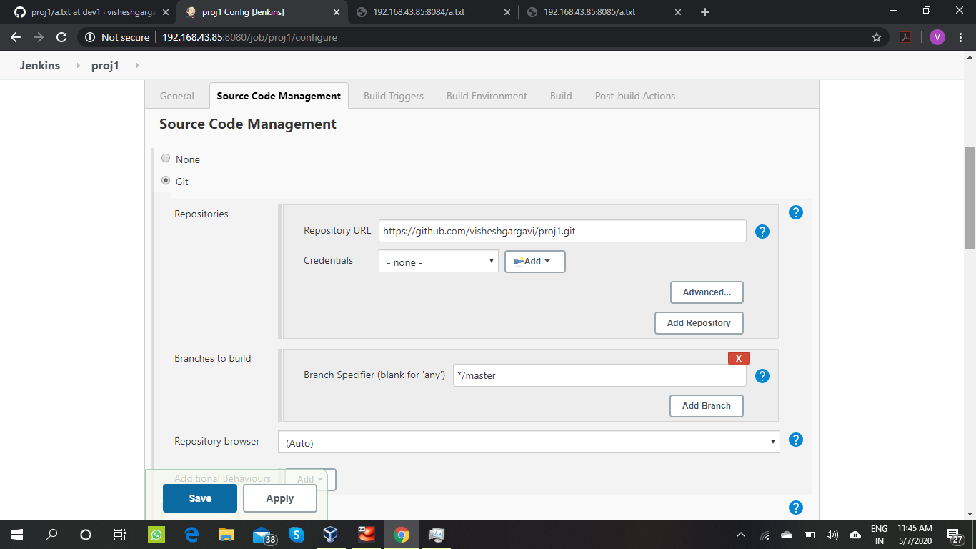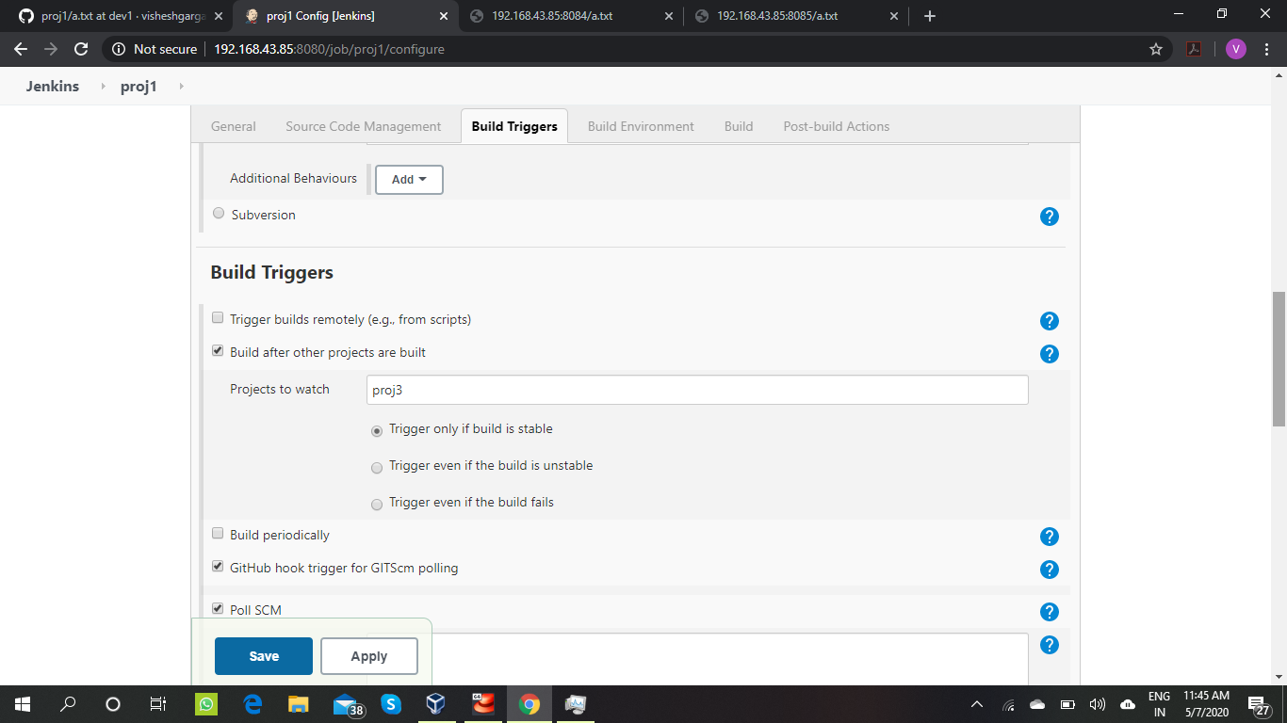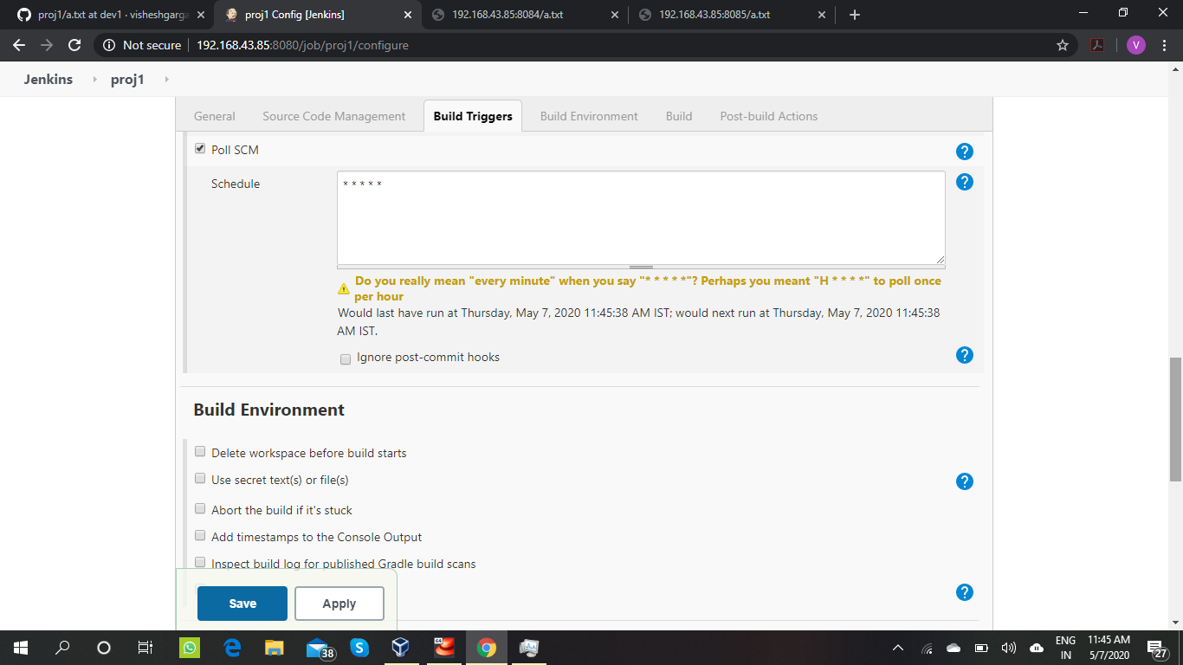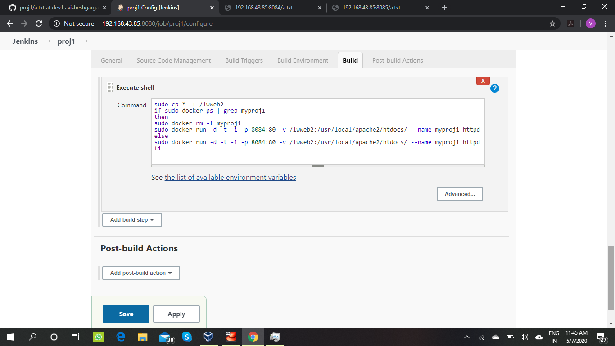

Setting up proj2

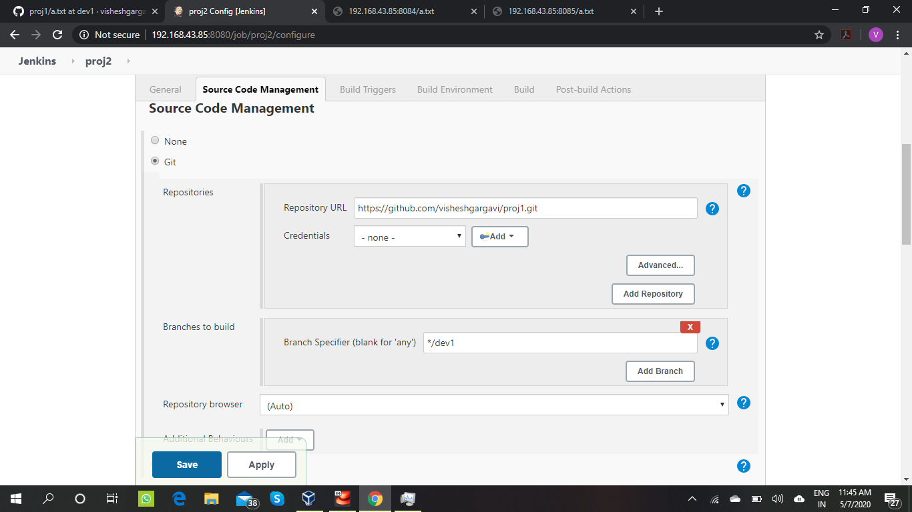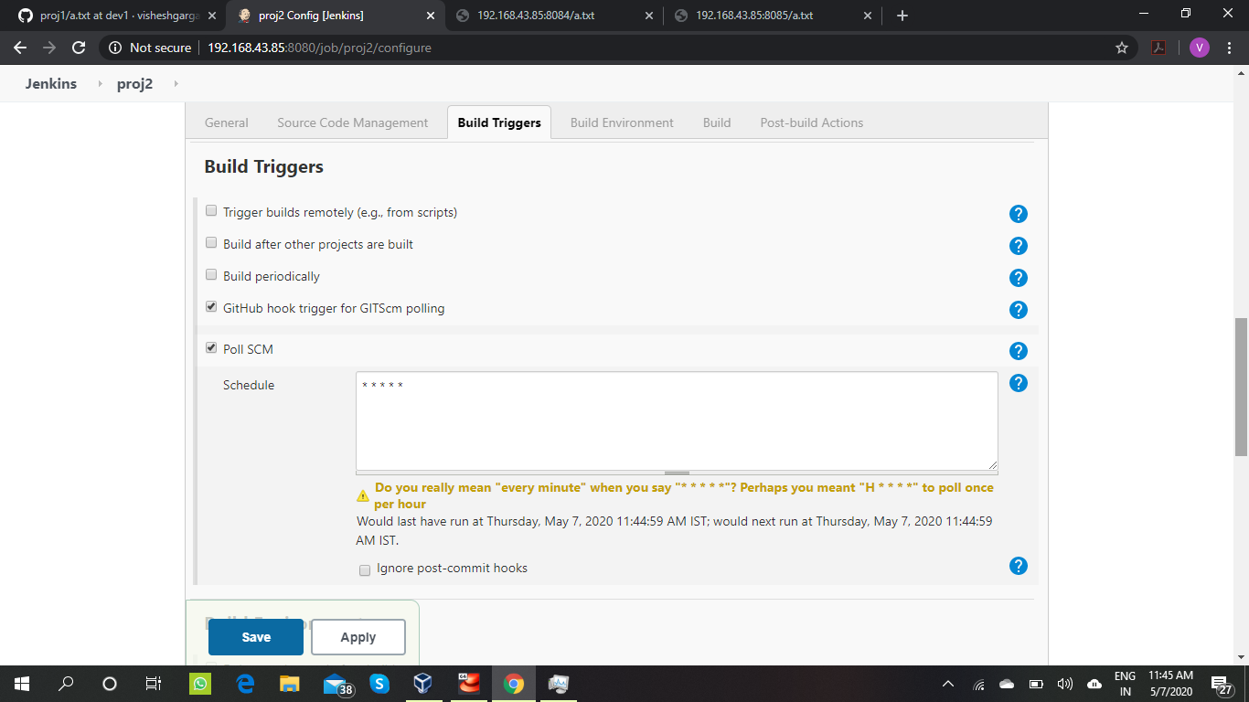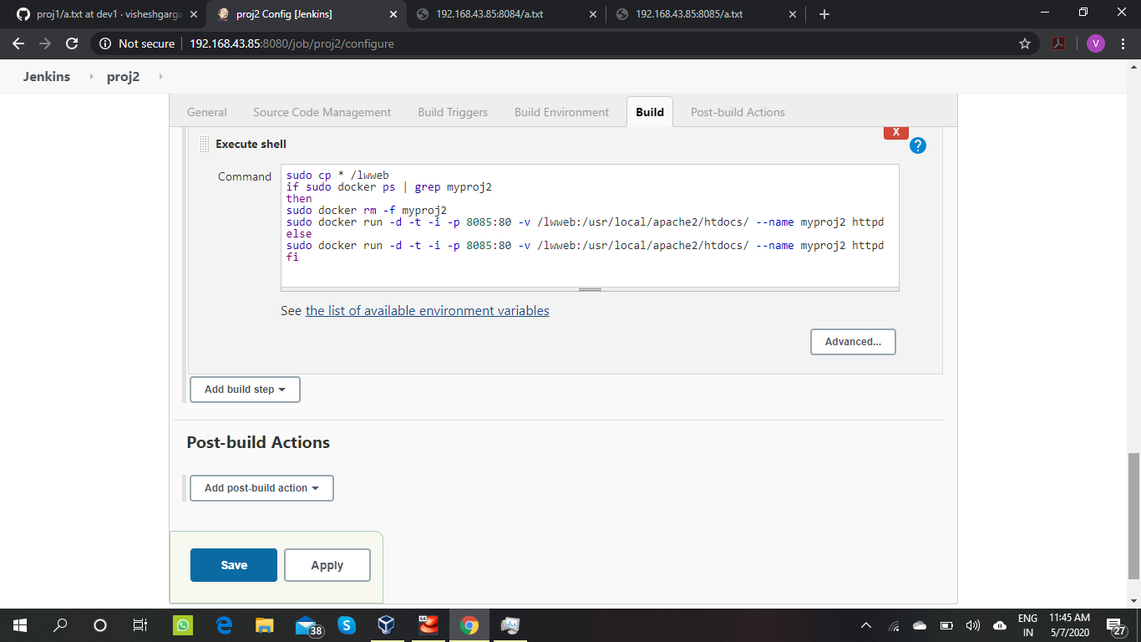

Setting up merge file

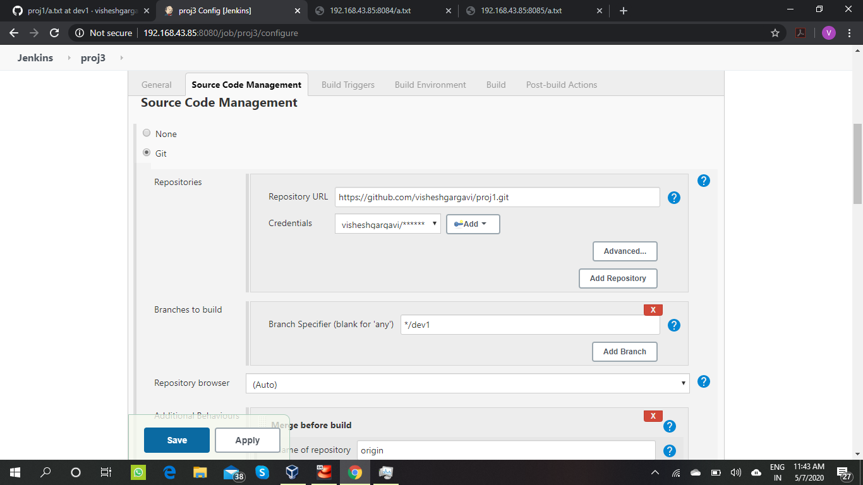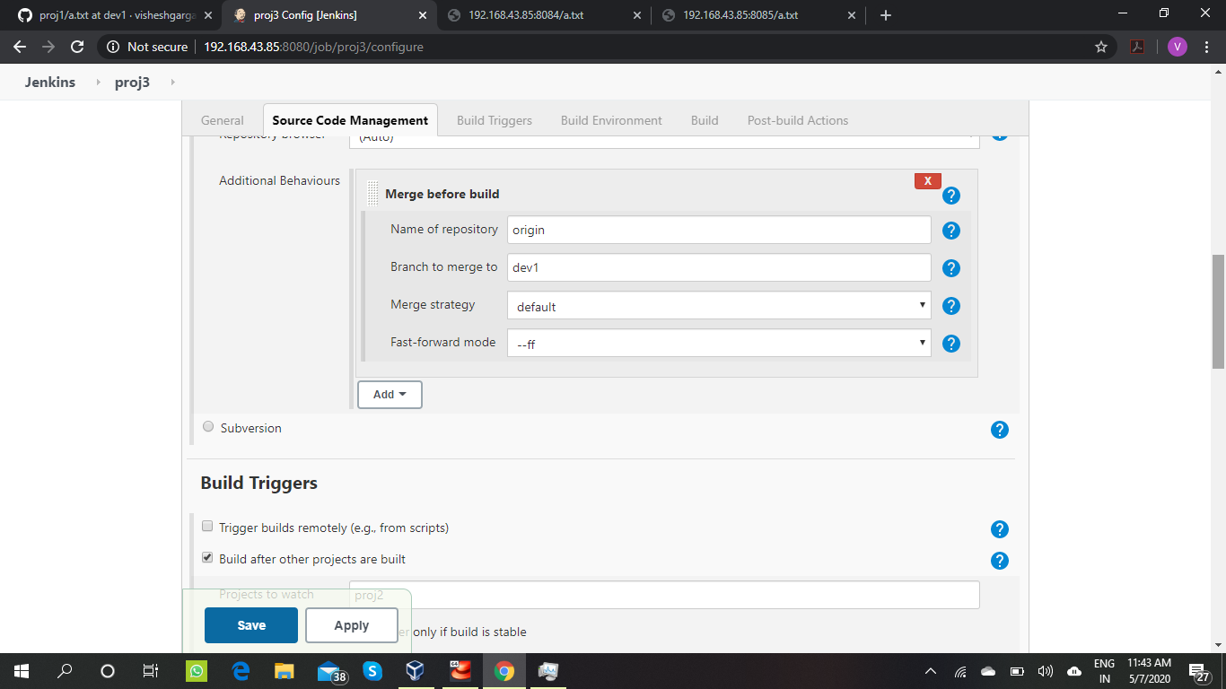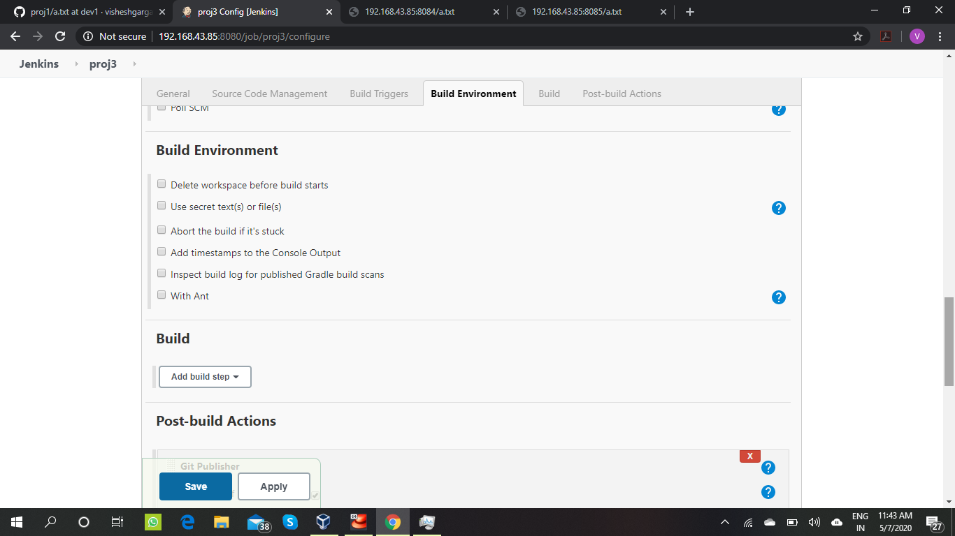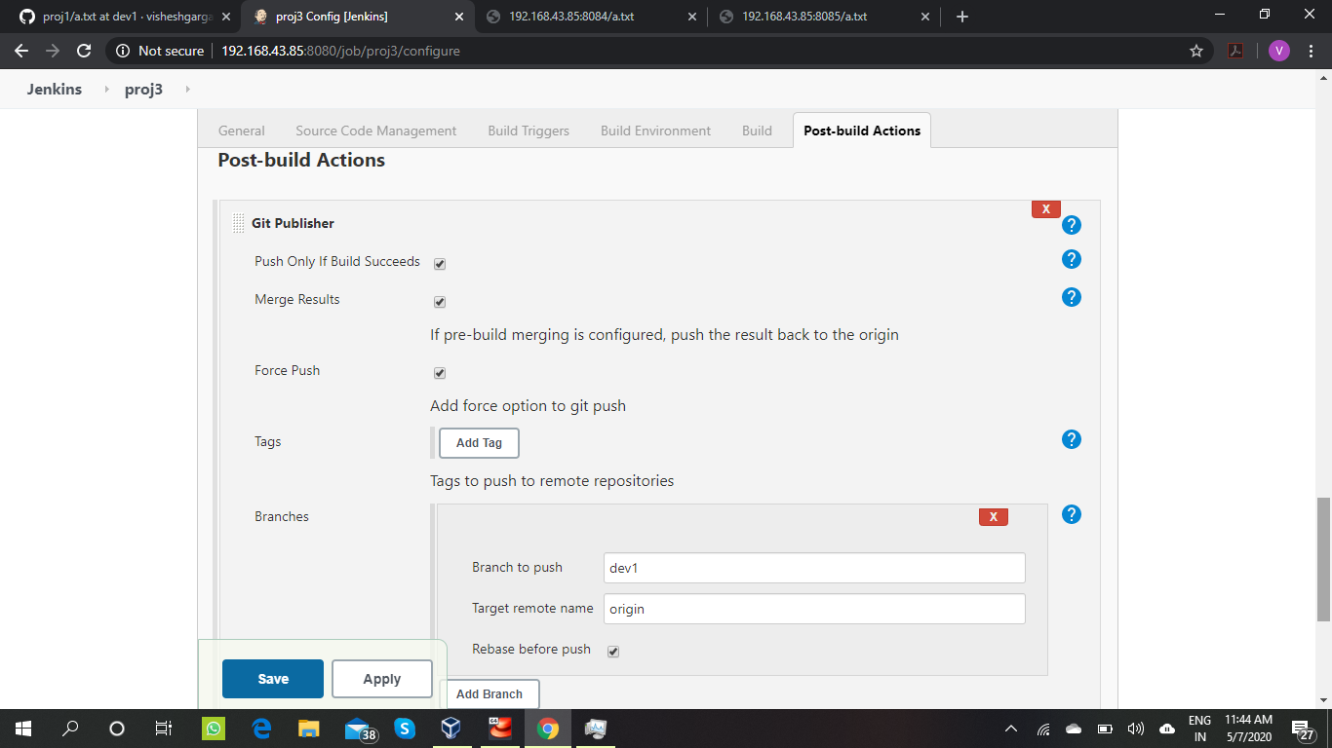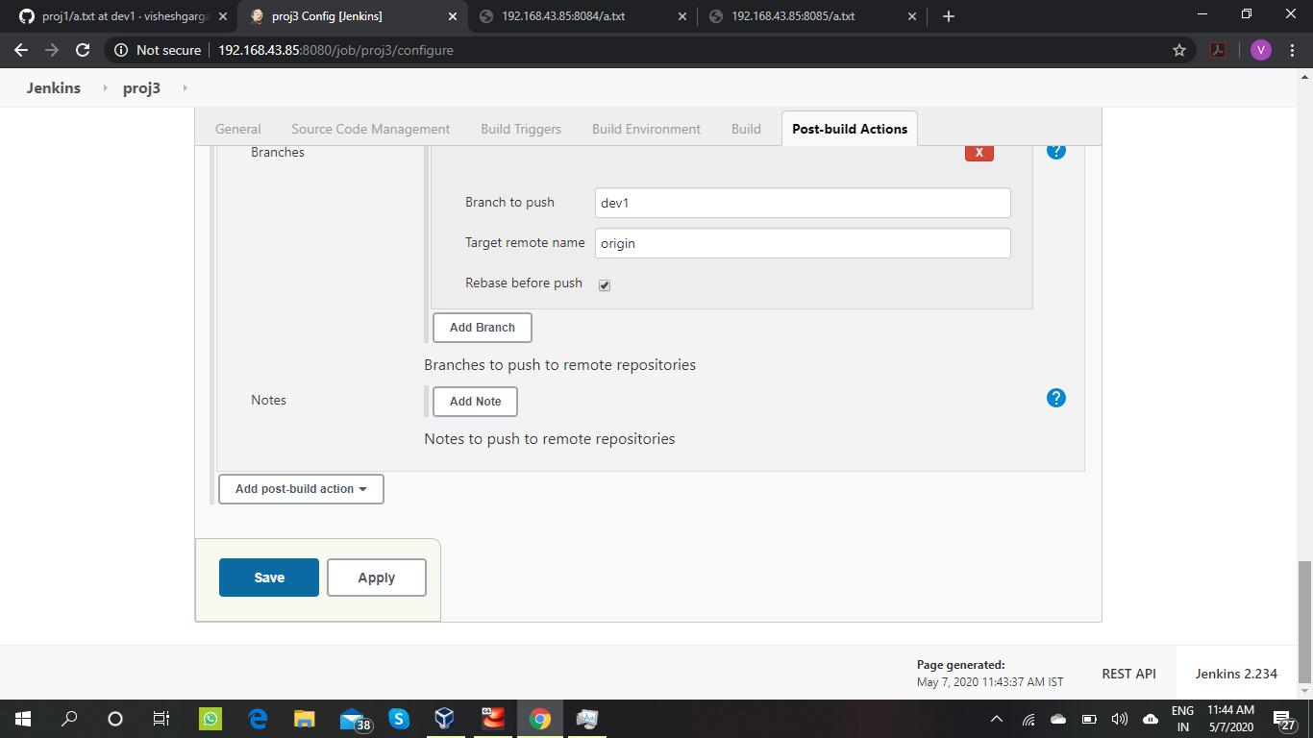

Output

